IEA Member Artist Profile
Linda Nunes
Artist As Entrepreneur
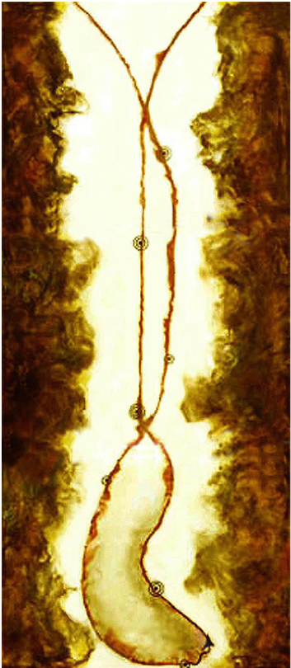
May 2023 Featured Artist
It turns out that Linda Nunes is a woman who possesses the passion and motivation to succeed, especially when it comes to the business of making, promoting, and selling her art. She is someone who takes her creativity very seriously and does all that she can to attract as many eyes as possible to that work.
Left: Life's Journey (triptych), 33" x 14", encaustic & mixed media by Linda Nunes
Growing up in the California Bay Area, Linda remembers how she demonstrated artistic talent as a young girl and how her dad always encouraged that gift. But back then, like many of us, Linda’s focus was on starting her adult life with the typical trappings of husband, home, and children. Linda knew that she wanted to study art formally but her family duties and finances took priority over her aspirations.
As time passed, family finances improved, her kids grew up and Linda and her husband finally felt the time was right for her to begin taking classes. Earning lower division credits at the local community college paved the way for Linda to eventually transfer to university in order to complete the requirements for a studio arts degree.
Exploring Linda’s website, especially the “About” page, clearly indicates her commitment to building a successful entrepreneurial art practice. Starting out as a more mature new graduate, Linda summoned the confidence to seek out opportunities to show her work. It’s apparent from her list of accomplishments that she is an artist who is willing to take risks in order to establish herself as part of her arts community.
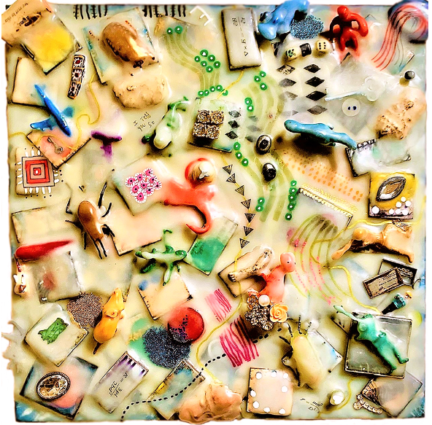
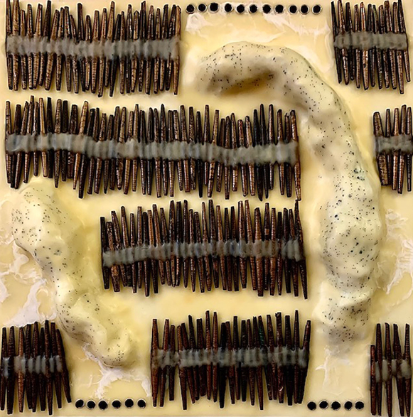
Her tactics include teaching classes and workshops, participating in juried shows, joining art centers, museums, and other art organizations, like International Encaustic Artists, heading up a team to create several exhibitions per fair season at California State Fair, volunteering where needed, etc.

Left: Holding Memories, 14" x 14", encaustic, vintage paper beads & mixed media by Linda Nunes
Right: Landfill, 14" x 14", encaustic, children's toys & other small items & mixed media by Linda Nunes
Linda embraces the idea of creating her own opportunities. She regards these events and occasions as chances to build her list of contacts and of potential venues where she can sell her art. “If I like the space and it feels as if my work would be compatible, I’ll ask if it’s ok to show my portfolio to the owner or manager by mail or in person.”
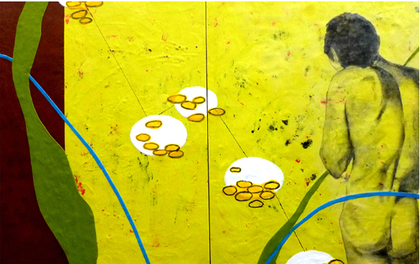
What inspires her? Visiting art galleries, museums, and art fairs is a favorite pastime. “I’m always interested in seeing what’s out there,” she says. “I never know what will spark my creativity or influence the next piece or series.” Drawn to abstract images, Linda’s encaustic paintings are teeming with vibrant color, contrast, and rhythm which all work together to pull the viewer in to take a closer look.

Above: Blue Line (Diptych), 30" x 48", encaustic, image transfer & mixed media by Linda Nunes
From the beginning, Linda enjoyed creating collages with water media. But about twenty years ago she discovered encaustic painting and instinctively wanted to learn more. “Back then, there wasn’t much information available but after a bit of research, I found Joanne Mattera‘s book, The Art of Encaustic Painting. It’s very informative and explains the history of the medium, popular techniques and which materials to use."
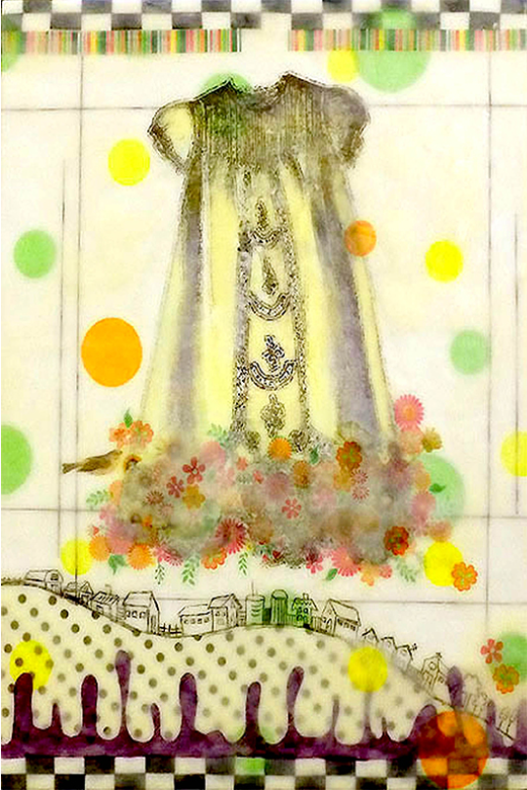
Eventually, Linda found out about Sierra Wax Artists, a local IEA affiliate, and signed up for classes with Charlotte Cooper, a well-regarded local wax artist. As time went by, Linda became an integral part of that group and is now proud of its accomplishments on behalf of regional encaustic artists. “The group has since disbanded” Linda explains, “but we were able to award several cash scholarships with leftover treasury funds”.

Left: Polka Dot Dress, 18" x 24", encaustic, image transfer & mixed media by Linda Nunes
When asked about her top tip, Linda replies, “It’s okay to treat your creative endeavor like a business rather than a hobby. I knew when I started that I wanted and needed to earn an income”, she states. “Over the years, I’ve come to know what my art is worth on the open market and so I have developed a pricing strategy that feels right for me and my clients. I also keep close track of all my income and expenses and frankly”, she adds, “I’m okay with paying taxes.”
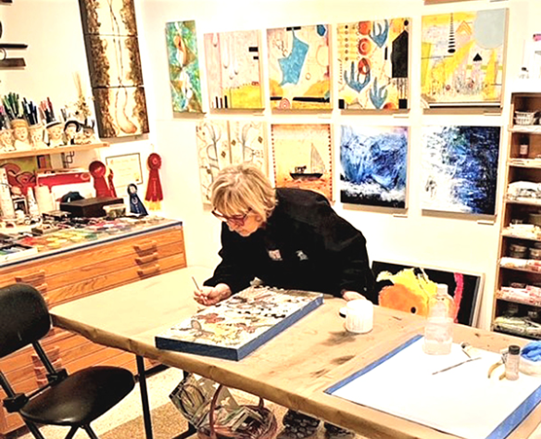
Gallery sales alone don’t always generate the level of income Linda requires, so she varies her outreach activities. Besides setting aside time to spend in her studio, Linda seeks out ways to show her work to as many people as possible by pursuing venues for solo and group exhibitions at galleries, museums, street fairs, or studio tours.
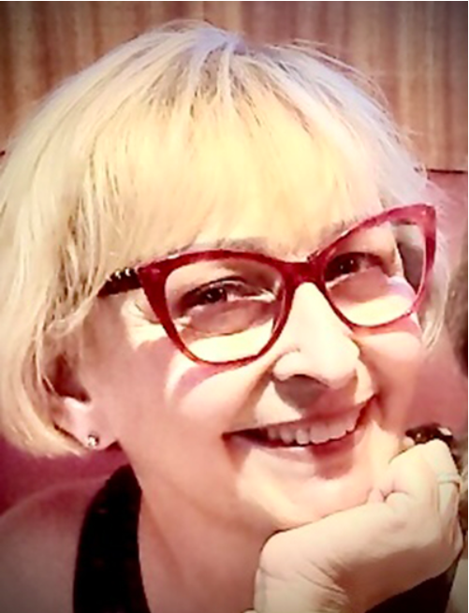
Linda also teaches encaustic classes and workshops several times a year and occasionally accepts commissions…which can be challenging but rewarding both creatively and financially. In fact, she’s currently working on a very large piece for a favorite client. Her process? Linda says she visits the client’s home or office which usually informs the color palette. Of course, she always asks about her client’s preferences and encourages input but as an abstract artist, the final design comes from her intuition and creativity. “So far, so good,” Linda reports.
Like any entrepreneur, Linda also tries to get her name in the media whenever the chance arises to generate a little buzz about her artwork. “You’ve got to stay ahead of technology, even though it can be a pain”, Linda declares.
True to her word, Linda and her art can be found on Facebook, LinkedIn and Instagram.

Want more info on workshops, demonstrations, events or her artwork?
Please visit Linda’s website: www.lindanunesart.com

Thank you to Artist Profile author, Lin Holzinger, for this delightful article about Linda Nunes!
Lin Holzinger is an avid encaustic painter and art advocate. Lin lives in a suburb of San Diego where she practices her art and enthusiastically demonstrates encaustic painting and monotype techniques to anyone who asks! www.linholzinger.com

